Assignment 1 (September 5 - 17)

1. Given the sets A = {1,2,3,4,6}, B = {2,4,6}, C = {1,5,6}. Find:
a) 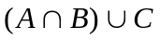 b) 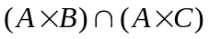

2. Given the sets A = {a,b,c,d,e}, B = {f,c,d}, C = {a,f,c}. Find:
1. 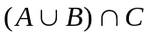 2. 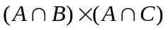

3. Find the direct product 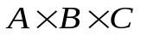, using the sets from the previous problem.

4. If the domain of the function y = 5 - 3x is the set 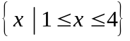, find the range of the function and express it as a set. Do the same for the function 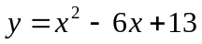.

5. Prove validity of the formula: 